**OVERALL**

Home Page

* can we make the first slider the video (<http://vimeo.com/90838380>) if not, lets put the video above the pics, but just as big.
* Intro slide show images are not the same size…. Slide 3, 5,6 need to be resized

FAQ page links back to home page

Experience has a video link that doesn’t work

2013 NNMF water marks on images - can this be re-cropped to remove this?

Title Block/Header – Can the images resize based on the computer screen? Dimension? See Below examples

Missing text to the right

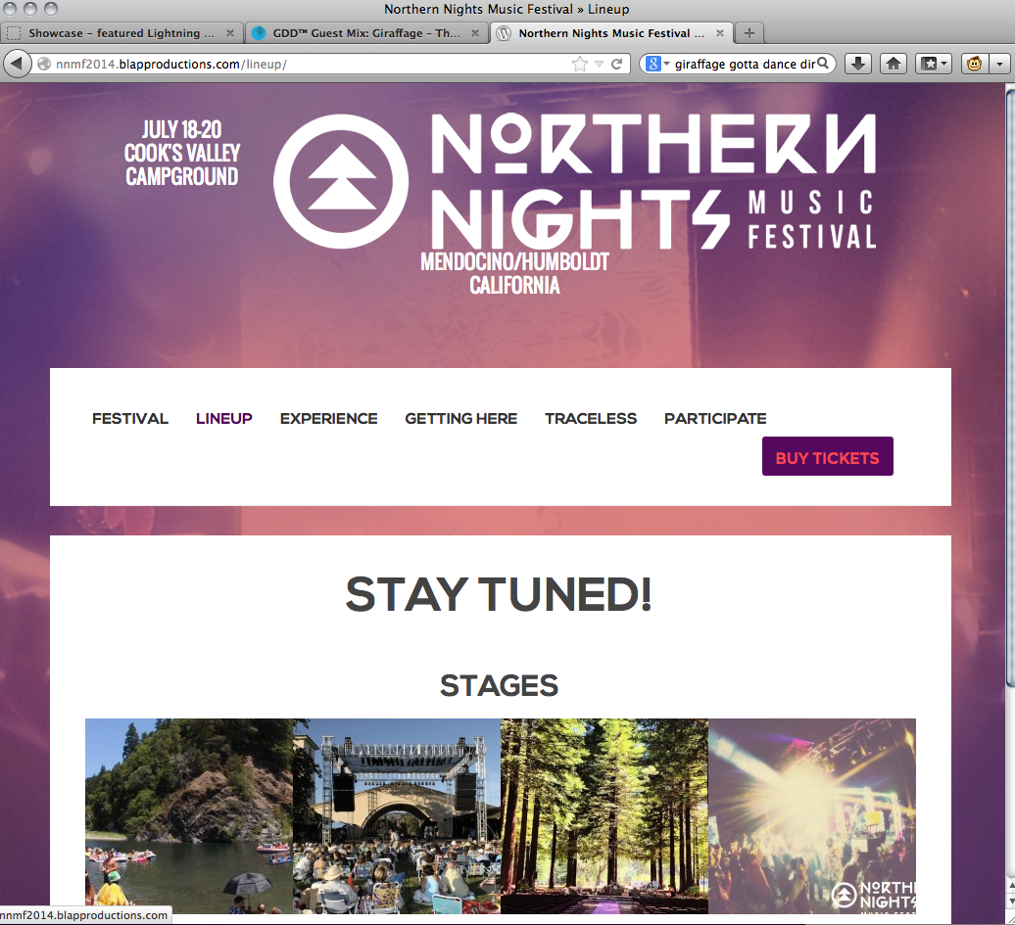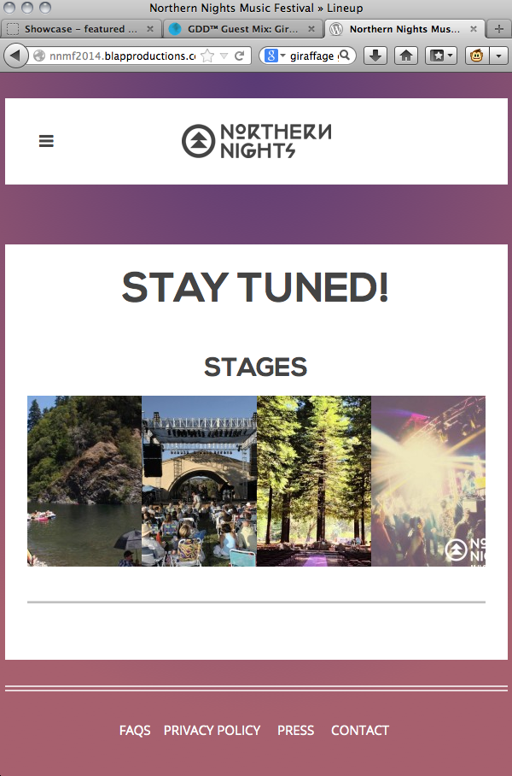

Google Analytics – need to make sure on the final site…

Texture – The white boxes for content and purple boxes are very plain – can we add some texture to these like in the original frequency theme example? That’s where we were going with the borders – just something more than the plain box edges. IS THIS A POSSIBILTY?

**FESTIVAL**

How do we easily add blog posts? – The first one should be the video.

Camping

* We need to remove some text from here is it best to do ourselves?

**EXPERIENCE**

video link that doesn’t work

Daytime Activities

–Anyway we can get the girls face the 5th pic

**GETTING HERE**

-Move bus pic down after carpool / above parking

-Switch bus with car pic titled "transportation photo"

**TRACELESS**

After the ecosystem tab box – all messed up with the photos displayed again

**PARTICIPATE**

Above info add photo titled “participate photo 1”

Volunteer

* change text to: Volunteer applications will be available when the lineup is announced! Please check back then.

Vendor

* change text to: Vendor applications will be available when the lineup is announced! Please check back then.

BUY TICKETS

- Link to new ticket page: [to follow](http://northernnights.inticketing.com/events/private" \t "_blank)